SESSION 16
Correlation Analysis
Assignment Notes with Worked Demo

1. Pearson Correlation

1.1 Definition
Correlation measures the strength and direction of the relationship between two variables. The Pearson correlation coefficient (r) measures the strength of the linear relationship between two numeric variables. It always lies between −1 and +1.
- r > 0 (positive): both variables tend to increase together.
- r < 0 (negative): as one variable increases, the other tends to decrease.
- r = 0: no linear relationship (a non-linear relationship may still exist).

1.2 Formula
r = Σ(x − x̄)(y − ȳ) / √[ Σ(x − x̄)² × Σ(y − ȳ)² ]
The numerator is the covariance part (how x and y move together). The denominator scales the result so that r is unit-free and stays between −1 and +1.

1.3 Interpreting the strength of r
Absolute value of r | Strength (rule of thumb)
0.00 to 0.19 | Very weak or no correlation
0.20 to 0.39 | Weak correlation
0.40 to 0.59 | Moderate correlation
0.60 to 0.79 | Strong correlation
0.80 to 1.00 | Very strong correlation

1.4 Assumptions
- Both variables are numeric (interval or ratio scale).
- The relationship is approximately linear.
- No extreme outliers, and the data are roughly normal for significance testing.

1.5 Example
Question: Find the Pearson correlation for x = 1, 2, 3, 4, 5 and y = 2, 4, 5, 4, 5.
Solution: x̄ = 3 and ȳ = 4. Deviations of x: −2, −1, 0, 1, 2. Deviations of y: −2, 0, 1, 0, 1.
- Σ(x − x̄)(y − ȳ): (4) + (0) + (0) + (0) + (2) = 6
- Σ(x − x̄)²: 4 + 1 + 0 + 1 + 4 = 10
- Σ(y − ȳ)²: 4 + 0 + 1 + 0 + 1 = 6
r = 6 / √(10 × 6) = 6 / 7.746 ≈ 0.775
Interpretation: a strong positive linear relationship.

2. Spearman Correlation

2.1 Definition
The Spearman rank correlation (ρ, rho) measures how well the relationship between two variables can be described by a monotonic function, that is, one that always moves in the same direction. It is the Pearson correlation calculated on the ranks of the data instead of the raw values.

2.2 Formula (when there are no tied ranks)
ρ = 1 − [ 6 Σd² / ( n (n² − 1) ) ]
Here d is the difference between the two ranks of each observation and n is the number of observations.

2.3 Pearson vs Spearman
Feature | Pearson (r) | Spearman (ρ)
Relationship | Linear | Monotonic (linear or curved)
Data used | Actual values | Ranks of values
Outliers | Very sensitive | Much less sensitive
Data type | Numeric | Numeric or ordinal
Use when | Linear trend, no big outliers | Skewed data, outliers, ranks or curved trend

2.4 Example
Question: Five students are ranked on hours studied (x = 10, 20, 30, 40, 50) and test score (y = 5, 15, 12, 40, 60). Find Spearman’s ρ.
Solution: Rank of x: 1, 2, 3, 4, 5. Rank of y: 1, 3, 2, 4, 5. Differences d: 0, −1, 1, 0, 0, so Σd² = 2.
ρ = 1 − (6 × 2) / (5 × 24) = 1 − 0.10 = 0.90
Interpretation: a very strong positive monotonic relationship.

3. Correlation Matrix
A correlation matrix is a table showing the correlation between every pair of variables in a data set. It is square and symmetric: the diagonal is always 1 (each variable is perfectly correlated with itself), and the value in row A, column B equals the value in row B, column A.

3.1 How to read it
- Diagonal: always 1.00, so it can be ignored.
- Look for strong pairs: values close to +1 or −1 show variables that move together or in opposite directions.
- Multicollinearity: predictors that are highly correlated with each other (for example above 0.8) cause problems in regression models.

3.2 Python (pandas)
df.corr(method="pearson") # default
df.corr(method="spearman")
df.corr(method="kendall")
A heatmap (Section 6) colours each cell of the matrix, which makes strong and weak relationships easy to spot at a glance.

4. Interpretation Pitfalls
A correlation coefficient is easy to calculate but easy to misread. Watch for the following mistakes.
Pitfall | Explanation
Correlation is not causation | A high r does not prove that x causes y. Ice-cream sales and drowning cases are correlated because both rise in hot weather.
Confounding variable | A third, hidden variable may drive both variables and create a false link.
Non-linear relationships | Pearson’s r can be near 0 even when a clear curved pattern exists (for example a U-shape). Always plot the data.
Outliers | A single extreme point can create or destroy a correlation. Check a scatter plot.
Restricted range | Using only part of the data range (for example only high earners) can weaken the apparent correlation.
Small samples | With few observations, a large r can occur by chance. Check the p-value and sample size.
Significance vs strength | A small p-value only means r is probably not zero. It does not mean the relationship is strong.
Combining groups | Pooling different groups can reverse or hide trends inside each group (Simpson’s paradox).

Good practice
- Always draw a scatter plot before trusting a correlation value.
- Use Spearman when data are skewed, ranked or contain outliers.
- Report the sample size and p-value together with r.
- Describe results as an association, not a cause, unless supported by an experiment.

5. Correlation Heatmap
A heatmap shows the correlation matrix as a coloured grid. Seaborn’s sns.heatmap() draws it in a single line. Useful options are:
- annot=True: prints the correlation value inside each cell.
- cmap="coolwarm": colour scale, usually red for positive and blue for negative.
- vmin=-1, vmax=1: fixes the colour scale to the full range of r so colours are comparable.
- fmt=".2f": shows values to two decimal places.

6. Demo: Correlation Heatmap with Seaborn

6.1 Problem statement
A store collected data on 12 customers: advertising spend (in thousands of Rs.), website visits, purchase value (Rs.) and customer age. Find which variables are related to purchase value, using Pearson and Spearman correlation, and draw a correlation heatmap. The figures are illustrative for this demo.

6.2 Python code
import pandas as pd
import seaborn as sns
import matplotlib.pyplot as plt

# Customer data (illustrative)
df = pd.DataFrame({
"ad_spend": [10, 12, 15, 18, 20, 24, 27, 30, 34, 38, 42, 45],
"website_visits": [200, 230, 260, 300, 310, 380, 420, 450, 520, 560, 600, 680],
"purchase_value": [310, 340, 330, 420, 400, 480, 470, 560, 540, 610, 650, 640],
"age": [45, 22, 38, 51, 29, 33, 41, 27, 36, 48, 31, 25],
})

# Pearson and Spearman correlation matrices
pearson = df.corr(method="pearson")
spearman = df.corr(method="spearman")
print(pearson.round(2))
print(spearman.round(2))

# Heatmap
sns.heatmap(pearson, annot=True, cmap="coolwarm", vmin=-1, vmax=1, fmt=".2f")
plt.title("Correlation Heatmap (Pearson)")
plt.show()

6.3 Output: Pearson matrix
ad_spend website_visits purchase_value age
ad_spend 1.00 1.00 0.98 -0.18
website_visits 1.00 1.00 0.97 -0.19
purchase_value 0.98 0.97 1.00 -0.16
age -0.18 -0.19 -0.16 1.00

6.4 Output: Spearman matrix
ad_spend website_visits purchase_value age
ad_spend 1.00 1.00 0.97 -0.20
website_visits 1.00 1.00 0.97 -0.20
purchase_value 0.97 0.97 1.00 -0.22
age -0.20 -0.20 -0.22 1.00

6.5 Heatmap
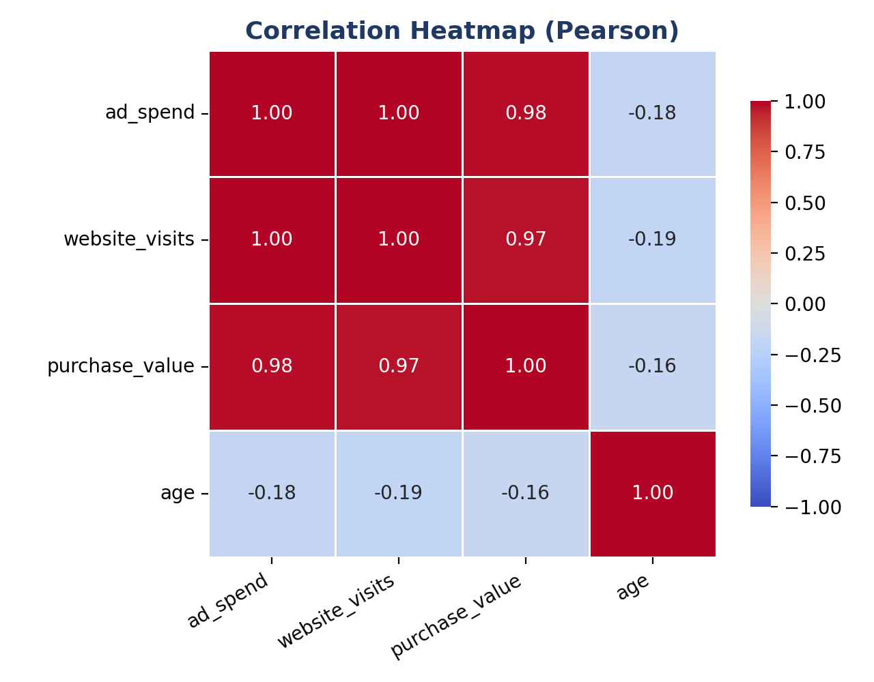
Figure 1: Pearson correlation heatmap (red = positive, blue = negative)

6.6 Interpretation
- Strong positive link: purchase value is very strongly correlated with ad spend (r = 0.98) and website visits (r = 0.97). Customers with higher ad exposure and more visits tend to spend more.
- Significance: for ad spend and purchase value, r = 0.98 with p < 0.001 (n = 12), so the relationship is very unlikely to be due to chance.
- Age: age has a weak negative correlation with every other variable (about −0.2). Age is not a useful predictor of purchase value in this data.
- Pearson vs Spearman: both matrices give almost the same values, which suggests the relationships are linear and not distorted by outliers.
- Multicollinearity: ad spend and website visits are almost perfectly correlated (about 1.00), so using both in one regression model would be redundant.
- Caution: these results show association only. They do not prove that advertising causes higher purchases, because other factors may be involved.

Key Takeaways
- Pearson (r): strength and direction of a linear relationship, from −1 to +1.
- Spearman (ρ): rank-based, handles monotonic relationships and is robust to outliers.
- Correlation matrix: all pairwise correlations in one table, shown with sns.heatmap().
- Pitfalls: correlation is not causation; check for outliers, non-linearity and confounders.

